

Semester Two Examination, 2020

Question/Answer booklet

MATHEMATICS SPECIALIST
UNITS 1&2

Section One:

Calculator-free

Your Name_______________________________

Your Teacher’s Name_____________________________

Time allowed for this section
Reading time before commencing work: five minutes
Working time: fifty minutes

Materials required/recommended for this section
To be provided by the supervisor
This Question/Answer booklet
Formula sheet

To be provided by the candidate
Standard items: pens (blue/black preferred), pencils (including coloured), sharpener, correction fluid/tape, eraser, ruler, highlighters

Special items: nil

Important note to candidates
No other items may be taken into the examination room. It is your responsibility to ensure that you do not have any unauthorised material. If you have any unauthorised material with you, hand it to the supervisor before reading any further.
Question | Mark | Max | Question | Mark | Max
1 |  | 4 | 6 |  | 5
2 |  | 9 | 7 |  | 7
3 |  | 7 | 8 |  | 5
4 |  | 9
5 |  | 4

Structure of this paper

Section | Number of questions available | Number of questions to be answered | Working time (minutes) | Marks available | Percentage of examination
Section One:  Calculator-free | 8 | 8 | 50 | 50 | 36
Section Two:  Calculator-assumed | 13 | 13 | 100 | 100 | 64
 |  |  |  | Total | 100

Instructions to candidates

- The rules for the conduct of the Western Australian Certificate of Education ATAR course examinations are detailed in the Year 12 Information Handbook 2020. Sitting this examination implies that you agree to abide by these rules.

- Write your answers in this Question/Answer booklet.

- You must be careful to confine your answers to the specific questions asked and to follow any instructions that are specific to a particular question.

- Additional pages for the use of planning your answer to a question or continuing your answer to a question have been provided at the end of this Question/Answer booklet. If you use the space to continue an answer, indicate in the original answer space where the answer is continued, i.e. give the page number.

- Show all your working clearly. Your working should be in sufficient detail to allow your answers to be checked readily and for marks to be awarded for reasoning. Incorrect answers given without supporting reasoning cannot be allocated any marks. For any question or part question worth more than two marks, valid working or justification is required to receive full marks. If you repeat any question, ensure that you cancel the answer you do not wish to have marked.

- It is recommended that you do not use pencil, except in diagrams.

- The Formula sheet is not to be handed in with your Question/Answer booklet.

See Next Page

Section One: Calculator-free (50 marks)

This section has 8 (eight) questions. Answer all questions. Write your answers in the spaces provided.

Spare pages are included at the end of this booklet. They can be used for planning your responses and/or as additional space if required to continue an answer.
● Planning: If you use the spare pages for planning, indicate this clearly at the top of the page.
● Continuing an answer: If you need to use the space to continue an answer, indicate in the original answer space where the answer is continued, i.e. give the page number. Fill in the number of the question that you are continuing to answer at the top of the page.

Working time: 50 minutes.

Question 1 (2.3.1) (4 marks)

Prove the following statement:

If $m$ and $n$ are odd integers, then $m^{2}-n^{2}$ is divisible by 4.

Solution
Assume that $m$ and $n$ are both odd integers.
Then $m=2k+1$ and $n=2l+1$ for some $k,l∈Z$, and so
$$m^{2}-n^{2}={\left(2k+1\right)}^{2}-{\left(2l+1\right)}^{2} \\ =4k^{2}+4k+1-\left(4l^{2}+4l+1\right) \\ =4k^{2}+4k-4l^{2}-4l \\ =4\left(k^{2}+k-l^{2}-l\right)$$
which is divisible by 4.
Hence $m^{2}-n^{2}$ is divisible by 4.
QED
Specific behaviours
assumes $m$ and $n$ are odd
expresses $m$ as $2k+1$ and $n$ as $2l+1$
expands and factorises ${\left(2k+1\right)}^{2}-{\left(2l+1\right)}^{2}$
concludes that $m^{2}-n^{2}$ is divisible by 4

Question 2 (2.2.1 - 2.2.3, 2.2.11) (9 marks)

- Let $M= \left[\begin{matrix}3 & 4 \\ 1 & -2\end{matrix}\right]$.

- Determine $M^{-1}$. (2 marks)
Solution
$\det\left(M\right)=3×\left(-2\right)-4×1=-10$
Hence $M^{-1}=-\frac{1}{10}\left[\begin{matrix}-2 & -4 \\ -1 & 3\end{matrix}\right]$

Specific behaviours
calculates determinant
writes correct expression for $M^{-1}$

- Showing use of an appropriate matrix equation together with your answer to part (i), determine the coordinates of the point of intersection of the lines
$3x+4y=-1$ and $x-2y=8$.
(3 marks)
Solution
Lines intersect at $(x,y)$ where $\left[\begin{matrix}x \\ y\end{matrix}\right]$ satisfies:
$$\left[\begin{matrix}3 & 4 \\ 1 & -2\end{matrix}\right]\left[\begin{matrix}x \\ y\end{matrix}\right]=\left[\begin{matrix}-1 \\ 8\end{matrix}\right]$$
Now
$$M^{-1}\left[\begin{matrix}3 & 4 \\ 1 & -2\end{matrix}\right]\left[\begin{matrix}x \\ y\end{matrix}\right]=M^{-1}\left[\begin{matrix}-1 \\ 8\end{matrix}\right] \\ \left[\begin{matrix}x \\ y\end{matrix}\right]=-\frac{1}{10}\left[\begin{matrix}-2 & -4 \\ -1 & 3\end{matrix}\right]\left[\begin{matrix}-1 \\ 8\end{matrix}\right] \\ =-\frac{1}{10}\left[\begin{matrix}-30 \\ 25\end{matrix}\right]$$
Hence the lines intersect at $(3,-\frac{5}{2})$

Specific behaviours
writes correct matrix equation
multiplies both sides by $M^{-1}$
states coordinates of point of intersection

- Consider the equation
$$\left[\begin{matrix}6 & 4 \\ k & -2\end{matrix}\right]\left[\begin{matrix}x \\ y\end{matrix}\right]=\left[\begin{matrix}-8 \\ 4\end{matrix}\right]$$

where $k∈R$.
- Determine the value of $k$ such that the equation does not have a unique solution for$\left[\begin{matrix}x \\ y\end{matrix}\right]$. (2 marks)
Solution
No unique solution if $\det\left[\begin{matrix}6 & 4 \\ k & -2\end{matrix}\right]=0$, which is true if $-12-4k=0$.
Hence if $k=-3$, the equation does not have a unique solution.

Specific behaviours
equates determinant to 0
states $k=-3$

- With the value of $k$ obtained in part (i), what is the geometrical relationship between the lines $6x+4y=-8$ and $kx-2y=4$? (2 marks)
Solution
With $k=-3$, the first equation is $-2$ times the second. Hence the lines are coincident.

Specific behaviours
states that equations are scalar multiples of each other
states that lines are coincident/same

Question 3 (2.3.4, 2.3.5) (7 marks)

Use the principle of mathematical induction to prove that

$$4+32+108+…+{4n}^{3}=n^{2}{\left(n+1\right)}^{2}$$

for all integers $n≥1$.
Solution
Let $P(n)$ stand for the statement ‘$4+32+108+…+{4n}^{3}=n^{2}{\left(n+1\right)}^{2}$’ for all $n∈Z^{+}$.

In $P(1)$:
$$LHS={4×1}^{3} \\ =4 \\ RHS=1^{2}{\left(1+1\right)}^{2} \\ =4$$

Hence LHS = RHS and so $P(1)$ is true.

Now assume that $P(k)$ is true for some integer $k≥1$.
Then $4+32+108+…+{4k}^{3}=k^{2}{\left(k+1\right)}^{2}$.

Now $LHS of P\left(k+1\right)=4+32+108+…+{4k}^{3}+{4\left(k+1\right)}^{3}$$$=k^{2}{\left(k+1\right)}^{2}+{4\left(k+1\right)}^{3} \\ ={\left(k+1\right)}^{2}(k^{2}+4\left(k+1\right)) \\ ={\left(k+1\right)}^{2}(k^{2}+4k+4) \\ ={\left(k+1\right)}^{2}{\left(k+2\right)}^{2} \\ ={\left(k+1\right)}^{2}{((k+1)+1)}^{2} \\ =RHS of P\left(k+1\right)$$

This shows that $P(k+1)$ is also true.

Hence, by PMI, $P(n)$ is true for all integers $n≥1$.
Specific behaviours
defines $P(n)$
shows that $P(1)$ is true by evaluating LHS and RHS separately
assumes $P(k)$ is true
writes LHS of $P(k+1)$ in terms of RHS of $P(k)$
simplifies expression to obtain${\left(k+1\right)}^{2}{\left(k+2\right)}^{2}$
concludes that $P(k+1)$ is also true
concludes proof by referring to PMI

Question 4 (2.3.7-2.3.10) (9 marks)

Let $z= 3-5i$ and $w=-2+i$. Write each of the following in the form $a+bi$ where $a,b∈R$.
- $z+w$ (2 marks)
Solution
$$z+w=3-2-5i+i \\ =1-4i$$
Specific behaviours
adds real and imaginary parts separately
states $1-4i$

- $3zw$ (2 marks)
Solution
$$3zw=3\left(3-5i\right)\left(-2+i\right) \\ =3(-6+3i+10i-5i^{2}) \\ =-3+39i$$
Specific behaviours
expands correctly
states $-3+39i$

- $z+\overline{z}$ (2 marks)
Solution
$$z+\overline{z}=3-5i+3+5i \\ =6$$
Specific behaviours
determines conjugate of $z$ or uses $z+\overline{z}=2Re(z)$
states $6$

- $\frac{z}{w}$ (3 marks)
Solution
$$\frac{z}{w}=\frac{3-5i}{-2+i}×\frac{-2-i}{-2-i} \\ =\frac{\left(3-5i\right)\left(-2-i\right)}{5} \\ =\frac{-11+7i}{5} \\ =-\frac{11}{5}+\frac{7}{5}i$$
Specific behaviours
multiplies numerator and denominator by $\overline{w}$
expands
states $-\frac{11}{5}+\frac{7}{5}i$ (must be in form $a+bi$ i.e. don’t accept $\frac{-11+7i}{5}$ as final answer)

Question 5 (1.2.11, 1.2.12) (4 marks)

Let $ΔOAB$ be an isosceles triangle with $OA=OB$, and let $X, Y$ and $Z$ be the midpoints of $\overline{OA}$, $\overline{OB}$ and $\overline{AB}$ respectively. Let $a=\vec{OA}$ and $b=\vec{OB}$.
Use a vector method to prove that $ΔXYZ$ is isosceles.

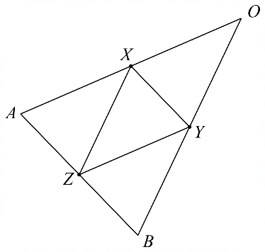

Solution
$$\vec{AB}=b-a \\ \vec{XZ}=\frac{1}{2}\vec{OA}+\frac{1}{2}\vec{AB} \\ =\frac{1}{2}a+\frac{1}{2}\left(b-a\right) \\ =\frac{1}{2}b \\ \vec{YZ}=\frac{1}{2}\vec{OB}-\frac{1}{2}\vec{AB} \\ =\frac{1}{2}b-\frac{1}{2}\left(b-a\right) \\ =\frac{1}{2}a$$
Thus $\left|\vec{XZ}\right|=\frac{1}{2}\left|b\right|$ and $\left|\vec{YZ}\right|=\frac{1}{2}\left|a\right|$.
But since $ΔOAB$ is isosceles, $\left|a\right|=|b|$, and hence $\left|\vec{XZ}\right|=\left|\vec{YZ}\right|$, meaning that $ΔXYZ$ is isosceles.
Specific behaviours
writes $\vec{AB}$ as $b-a$
shows that $\vec{XZ}=\frac{1}{2}b$
shows that $\vec{YZ}=\frac{1}{2}a$
deduces from $\left|a\right|=|b|$ that $\left|\vec{XZ}\right|=\left|\vec{YZ}\right|$

Question 6 (2.1.3 - 2.1.6, 2.1.8) (5 marks)

Prove that the following is true for all $θ$.

$$\cot{θ}-2\cot{2θ}=\tan{θ}$$

Solution
$$LHS=\cot{θ}-2\cot{2θ} \\ =\frac{\cos{θ}}{\sin{θ}}-\frac{2\cos{2θ}}{\sin{2θ}} \\ =\frac{\cos{θ}}{\sin{θ}}-\frac{2\cos{2θ}}{2\sin{θ}\cos{θ}} \\ =\frac{2\cos^{2}{θ}-2\left(2\cos^{2}{θ}-1\right)}{2\sin{θ}\cos{θ}} \\ =\frac{\cos^{2}{θ}-2\cos^{2}{θ}+1}{\sin{θ}\cos{θ}} \\ =\frac{1-\cos^{2}{θ}}{sinθcosθ} \\ =\frac{\sin^{2}{θ}}{\sin{θ}\cos{θ}} \\ =\frac{\sin{θ}}{\cos{θ}} \\ =\tan{θ} \\ =RHS$$
Hence $\cot{θ}-2\cot{2θ}=\tan{θ}$ for all $θ$.
Specific behaviours
writes cot expressions using $\frac{\cos{}}{\sin{}}$
combines to give a single fraction
using double angle formula for cos
simplifies to $\frac{\sin{θ}}{\cos{θ}}$
works from LHS to RHS (or vice versa)

Question 7 (1.3.2, 1.3.5, 2.3.1) (7 marks)

- Let $p$ be an irrational number and $q$ a rational number. Use the method of proof by contradiction to prove that $pq$ is irrational. (4 marks)
Solution
Assume that $p$ is irrational and $q$ is rational, but that $pq$ is rational.
Then $q=\frac{a}{b}$ and $pq=\frac{c}{d}$ for some integers $a$, $b$, $c$ and $d$.
Now
$$p=pq÷q \\ =\frac{c}{d}÷\frac{a}{b} \\ =\frac{c}{d}×\frac{b}{a} \\ =\frac{cb}{da}$$
which is rational since $cb$ and $da$ are integers. This contradicts the assumption that $p$ is irrational; hence $pq$ must be irrational.
Specific behaviours
assumes that $pq$ is rational
writes $q$ and $pq$ as a ratio of integers
shows that $\frac{pq}{q}$ is rational
notes contradiction and concludes that $pq$ is irrational

- State whether the following is true or false and prove or disprove it accordingly:
‘If $p$ is irrational and $q$ is rational, then ${\left(p+q\right)}^{2}$ is irrational.’
(3 marks)
Solution
The statement is false.
E.g. let $p=\sqrt{2}-1$ and $q=1$. Then $p$ is irrational and $q$ is rational, but ${\left(p+q\right)}^{2}=2$, which is rational.
Specific behaviours
states false
gives counterexample values for $p$ and $q$
shows that ${\left(p+q\right)}^{2}$ is rational for those values

Question 8 (2.1.7) (5 marks)

The diagram below shows the graphs of two functions $f\left(x\right)=3\cos{(x)}$ and $g\left(x\right)=a\sin{(x)}$ where $a$ is a real constant.
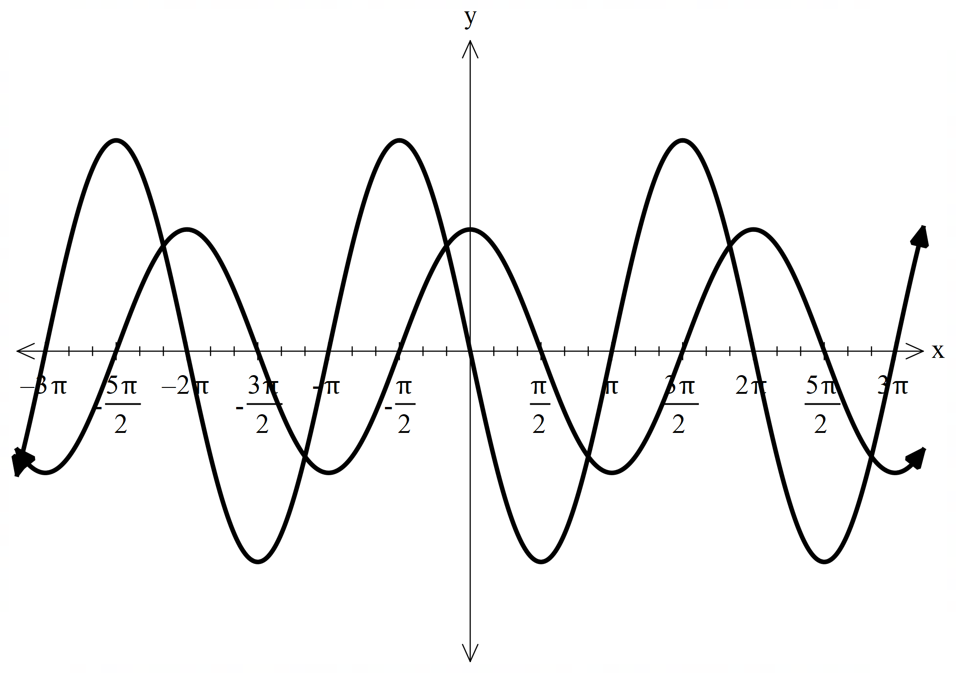
Below is the graph of $y=f\left(x\right)+g(x)$, which can also be expressed as $y=b\sin{(x+α)}$ where $b$ and $α$ are positive real constants.
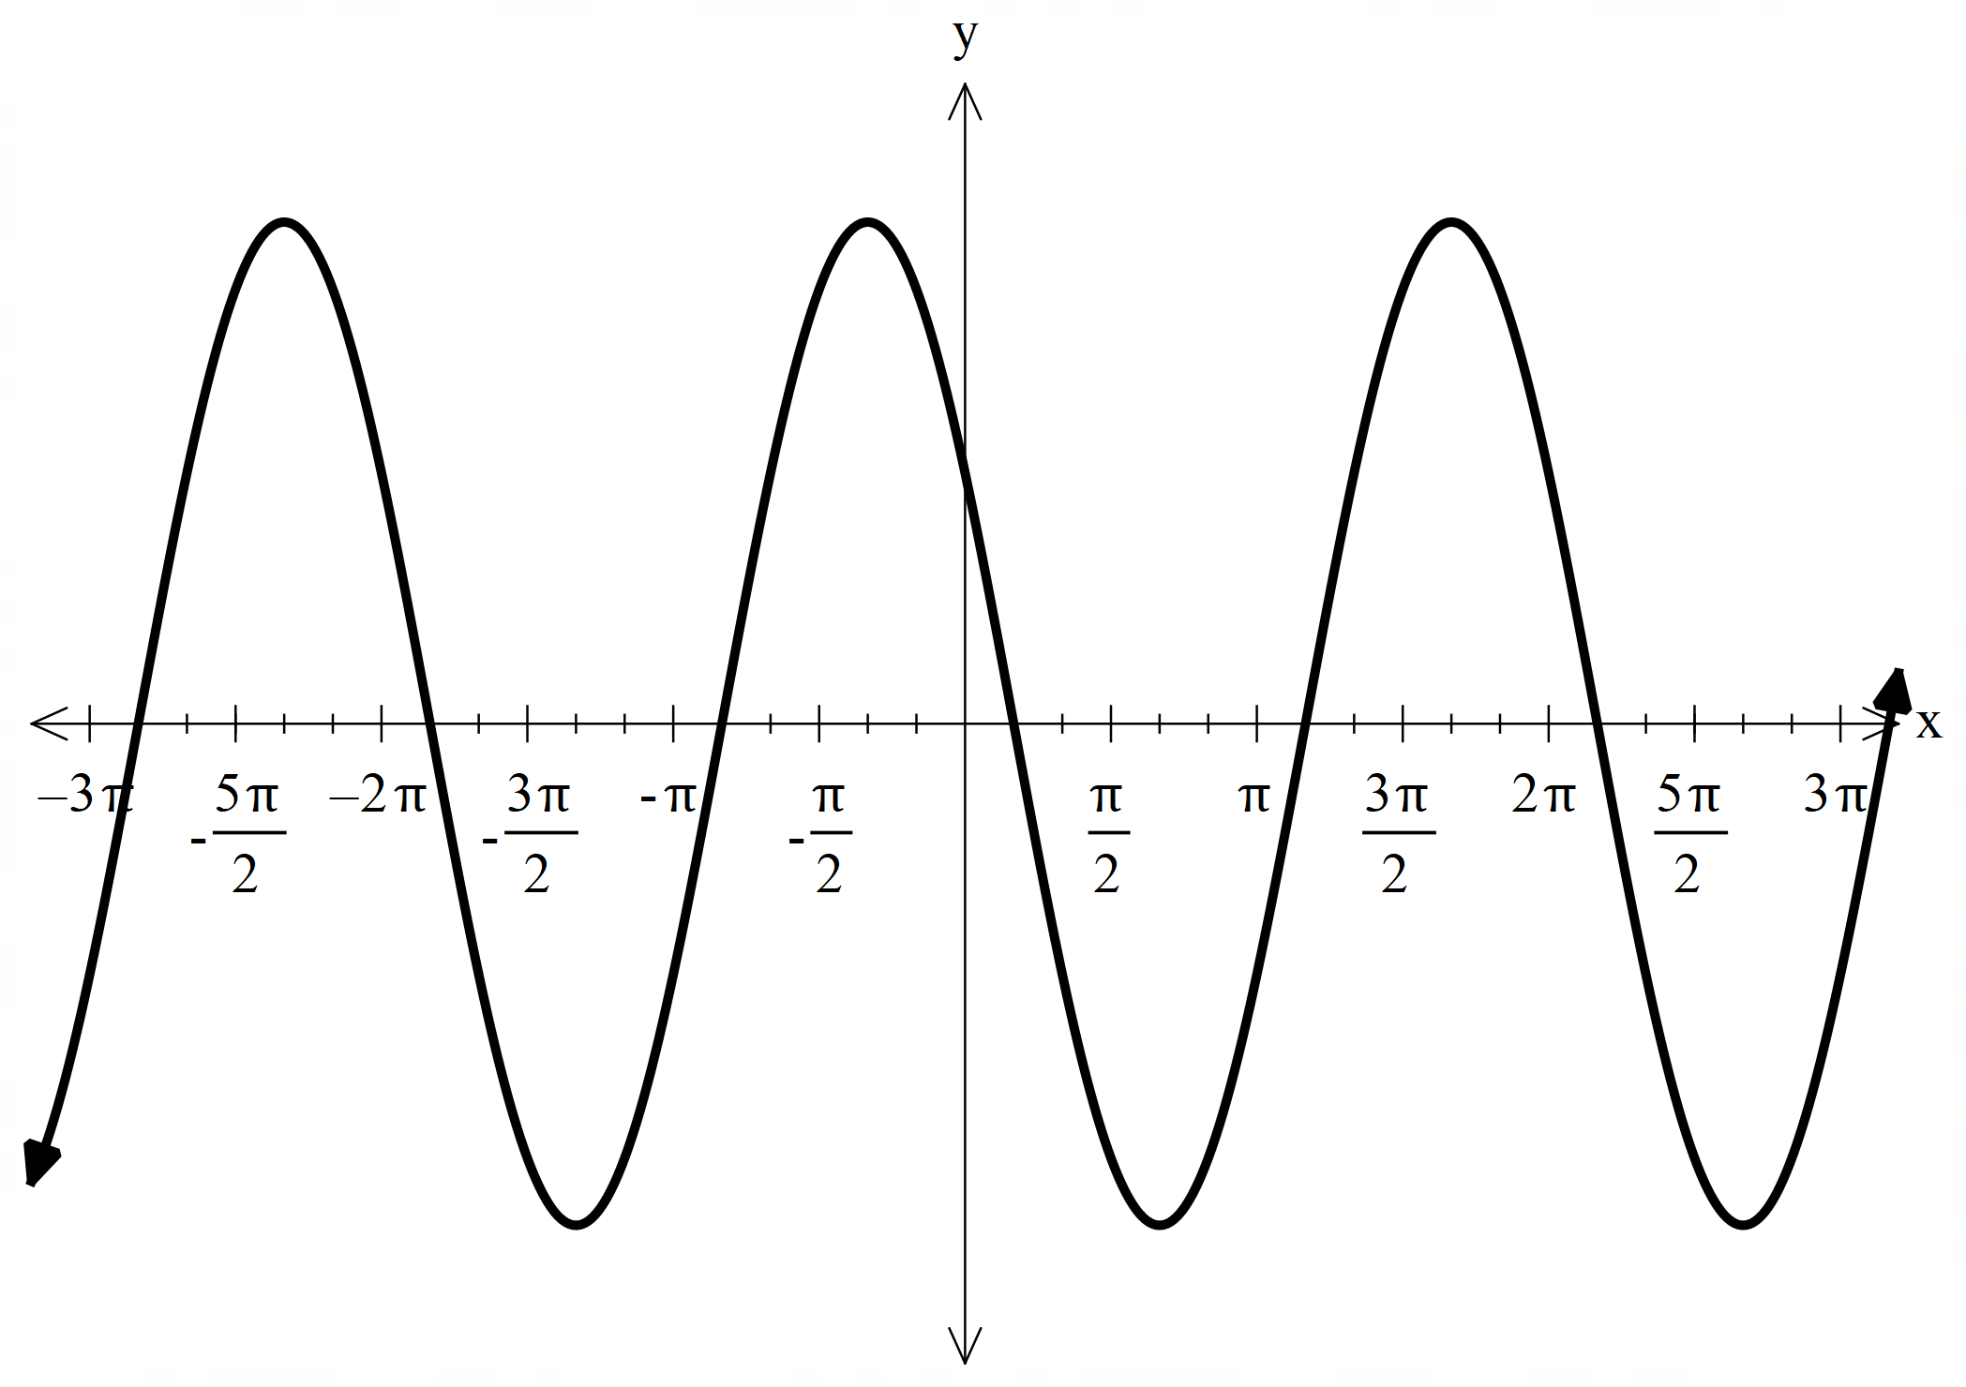

- Determine an exact value for $α$. (1 mark)
Solution
$$α=\frac{5π}{6}$$

Specific behaviours
states correct value

- Determine the values of$a$ and $b$. (4 marks)
Solution
Equation of graph is
$$y=b\sin\left(x+\frac{5π}{6}\right) \\ =b\sin{x}\cos{\frac{5π}{6}}+b\cos{x}\sin{\frac{5π}{6}} \\ =b\left(-\frac{\sqrt{3}}{2}\right)\sin{x}+b\frac{1}{2}\cos{x}$$
Since the equation of the graph is also $y=a\sin{x}+3\cos{x}$, we have $\frac{b}{2}=3$, so $b=6$.
Hence $a=6\left(-\frac{\sqrt{3}}{2}\right)=-3\sqrt{3}$.

Specific behaviours
notes that $y=b\sin\left(x+\frac{5π}{6}\right)$
expands using compound angle formula
solves for $b$ and states correct value
solves for $a$ and states correct value

END OF SECTION ONE

Additional working space
Question number:

Additional working space
Question number:

